1. **Basic Arduino functions**
   1. *Explain the function of the digitalWrite(pin, value).*

digitalWrite(pin, value) write a HIGH (on, Vcc = 5V) or a Low (off, GND = 0V) value to a digital pin.

* 1. *Explain the function of the analogWrite(pin, value) when Arduino Nano is used.*

analogWrite(pin value) uses a pulse width moderation (PMW) to write an analog voltage, which is the value between 0 = GND and 255 = Vcc.

* 1. Is Arduino Nano possible to have analog voltage output (Which is not GND or supply voltage level) without additional circuit configuration? Explain why the answer is yes or no

Yes. As described in 2-1, it uses PMW to make effective voltage between GND and Vcc. We can add RC filter to flatten the signal though.

* 1. *Explain the function of the analogRead(pin)*

analogRead(pin) reads the input voltage in value between 0 = GND and 1023 = Vcc.

* 1. *What are the minimum value and maximum value of analogRead(pin) when Arduino Nano is used? In the ideal case with 5-v supply voltage, what is the resolution of analog-to-digital converter (ADC) in Arduino Nano?*

Minimum value (0) = GND = 0V, and maximum value (1023) = Vcc = 5V.

The resolution would be 5/210= 4.88mV.

1. **PWM based DAC**

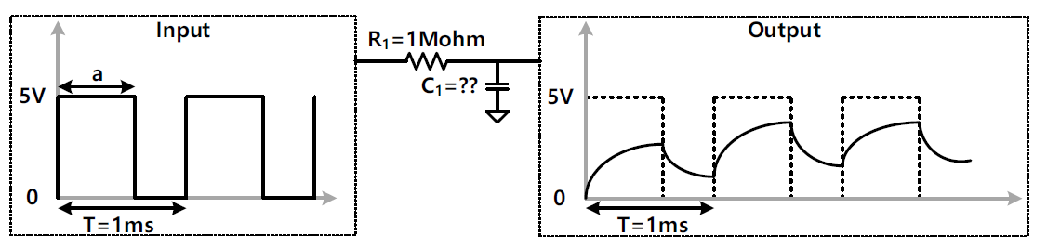

1. *What is* ***a*** *value that has the maximum ripple of output signal in the steady state?*

To make maximum ripple, it should behave by 50% PMW, which means duty cycle a = 0.5ms

1. *What is peak-to-peak voltage of ripple when C1 = 1nF?*

.

*.*

.

.

1. *What is the maximum capacitance of C1 to make peak-to-peak voltage of ripple less than 250 mV?*

In order to make peak-to-peak voltage of ripple be 250mV, $\frac{(1-e^{-\frac{a}{τ}})(1-e^{-\frac{T-a}{τ}})}{1-e^{T/τ}}=\frac{1}{20}$.

$\frac{T}{τ}=0.086.$ Thus, Thus C1 should be 11.6nF.

1. *As the capacitance of C1 increases, does peak-to-peak voltage of ripple increase or decrease?*

As we could see in 2,3) peak-to-peak voltage of ripple decreases as C­1 increases.

1. *As the capacitance of C1 increases, does setting time of output signal increase or decrease?*

Setting time is the time required for the response curve to reach and stay within a range of certain percentage of the final value.

Thus, setting time would increase as $τ$ increases (C1 increases)